* **Change table –**

|  |  |  |  |  |  |
| --- | --- | --- | --- | --- | --- |
| **Sr.**  **no** | **Change in colour** | **Description** | **suggestion** | **Suggested to** | **remarks** |
| **1.** |  |  |  |  |  |
|  |  |  |  |  |  |
|  |  |  |  |  |  |
|  |  |  |  |  |  |

B.K. Jewellers

**Business Requirement Document (BRD)**

**Document for**

**“Manufacturing” part.**

Document NO: 001

Date: 09-02-2020

Prepared by:

Group 2

* **Table of Contents** -

|  |  |
| --- | --- |
| 1. | Introduction |
|  | 1.1 Purpose |
|  | 1.2 Scope |
|  |  |
| 2. | General business requirements |
|  | 2.1 General requirement |
|  | 2.2 User characteristics |
|  |  |
| 3. | Business requirement |
|  |  |
| 4. | Use case diagram |
|  |  |
| 5. | Process description |
|  |  |
| 6. | Business data model |
|  |  |
| 7. | Accuracy |
|  |  |
| 8. | Impacts |

1. **Introduction**
   1. Purpose:

The purpose of making business requirement document is to make complex operations of manufacturing department simpler and easier.

* 1. Scope:

The scope of this business requirement document is bounded to only to requirements of “manufacturing department” of **B.K. Jewellers**.

The scope includes:

|  |  |
| --- | --- |
| 1. | Work activity, |
| 2. | Manufacturing activity, |
| 3. | Stock (raw material) maintenance. |

1. **General requirements**
   1. General requirements:

* Only one user on one system.
* Jewellery transferring after completion of making process.
* A new voucher number generation on beginning of every new making process of jewellery.
* Printing receipts in pre-defined format automatically.
  1. User characteristics:

|  |  |  |
| --- | --- | --- |
| Name | No. Of user | Responsibility/activity |
| Manufacturing manager | 1 | He/she have 80% of computer knowledge and 95% of knowledge of jewellery making process. |

1. **Business requirement**

|  |  |
| --- | --- |
| 1. | Login |
| Priority | High |
| Originator | Managing director |
| Inputs | Username and password from text fields submit and reset from a button. |
| Operations | When username and password is added, values will validate. |
| Outputs | If successful, user will navigated into software else the text fields will become red. |
| Error handling | If the inputted data is incorrect it will show an alert message “username and password is wrong!!”. |
| User need | User needs this for login to the software. |
| Benefits | First level of security to access the software. |

|  |  |
| --- | --- |
| 2. | Work receipt (for each worker) |
| Priority | High |
| Originator | Managing director |
| Inputs | Adding values (name of worker, type of work, start date, end date, raw material given) in text fields. |
| Operations | When all inputs are submitted, a preview of an receipt will generated with provided data. |
| Outputs | Display the receipt in predefined format. |
| Error handling | If software is unable to generate receipt, an alert massage will shown “Unable to generate receipt, please try again.”.  If any hardware issue, entered data will be deleted and user will have to restart the software. |
| User need | User needs this requirement for keeping track of every worker and work given to them. |

|  |  |
| --- | --- |
| 3. | Material stock report (monthly) |
| Priority | High |
| Originator | Managing director |
| Inputs | Adding values manually in provided text fields. |
| Operations | When values were added a report will generated with entered details. |
| Outputs | Display the report in organization’s format. |
| Error handling | If software is unable to generate report, an alert massage will shown “Unable to generate report, please try again.”.  If any hardware issue, entered data will be deleted and user will have to restart the software. |
| User need | User needs this requirement to manage the stock of raw materials needed for manufacturing of jewellery. |
| Benefits | A monthly report will inform the responsible person to make sufficient stock as soon as possible. |

|  |  |
| --- | --- |
| 4. | Manufactured jewellery report |
| Priority | High |
| Originator | Managing director |
| Inputs | Adding values manually in provided text fields. |
| Operations | When values were added a voucher will generated with entered details. |
| Outputs | Display the report in organization’s format. |
| Error handling | If software is unable to generate voucher, an alert massage will shown “Unable to generate voucher, please try again.”.  If any hardware issue, entered data will be deleted and user will have to restart the software. |
| User need | User needs this requirement for generating barcodes stickers and unique identify code. |
| Benefits | A voucher will be helpful for other departments (sales) to understand the item details |

1. **Use case diagram**

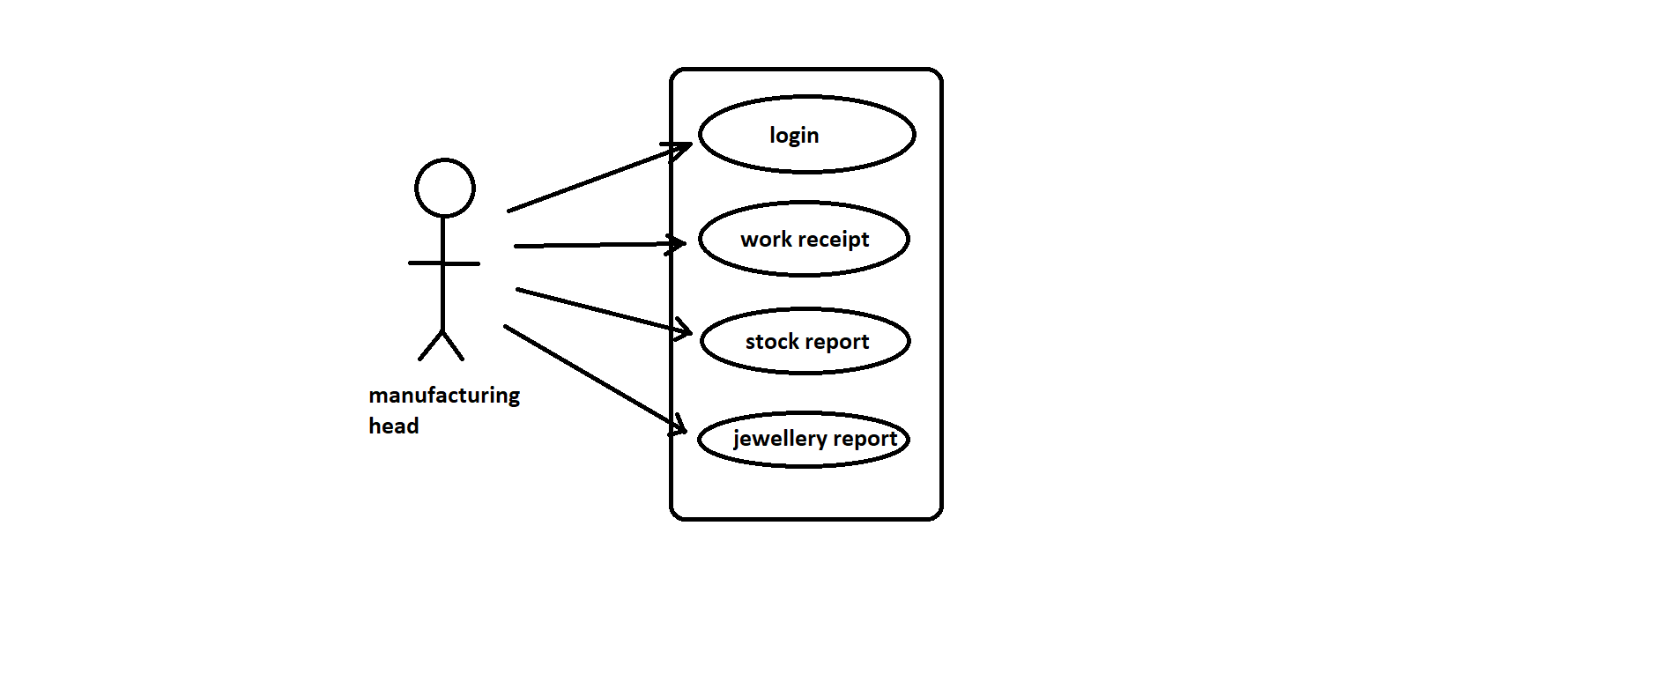

|  |  |
| --- | --- |
|  | Indicates software. |
|  | Indicates modules. |
|  | Indicates access/rights. |
|  | Indicates users. |

1. **Process description**

|  |  |
| --- | --- |
| Details | Process Description |
| Process Name | Login |
| Purpose | It should be the first process for entering to software. |
| priority | High |
| Frequency/Duration | Login process should not more than 2seconds to complete and navigate the user to the main page of the software. |

|  |  |
| --- | --- |
| Details | Process Description |
| Process Name | Carat calculation. |
| Purpose | It should be the process done for making exact purity of gold or silver. |
| priority | High |
| Frequency/Duration | This process will take maximum 2 seconds to calculate the entered data. |

|  |  |
| --- | --- |
| Details | Process Description |
| Process Name | Work report generation. |
| Purpose | It should be the process done before giving any new work to worker to keep record of worker and given work. |
| priority | High |
| Frequency/Duration | This process will take maximum 2 seconds to generate a preview of a report with submitted data.  When report will sent to get printed, instruction to the connected printer will send within 1.5-2 sec. |

|  |  |
| --- | --- |
| Details | Process Description |
| Process Name | Stock report generation. |
| Purpose | It should be the process done for managing stock of raw material in manufacturing department. |
| priority | High |
| Frequency/Duration | This process will take maximum 2 seconds to generate a report when all data will be submitted. |

|  |  |
| --- | --- |
| Details | Process Description |
| Process Name | Jewellery report generation. |
| Purpose | It should be the process done after completion of making of any jewellery.  It is used for detailed knowledge of particular jewellery to sales department and for generating of barcode stickers and unique identity code. |
| Priority | High |
| Frequency/Duration | This process will take maximum 3 seconds to generate report after submitting the data. |

1. **Business data model**

**---------(N/A)---------**

Note: insufficient knowledge.

1. **Accuracy**

The accuracy will always be higher in any of the functions which can be done by the software even in printing the invoices. All the automatic processes will be completed with very high level of accuracy in the results generated by them.

1. **Impacts**

**---------(N/A)---------**

Note: first phase of making software.